**PRACTICAL NO.11**

**a. Programming Media API and Telephone API**

**Code:**

**activity_main.xml**

<?xml version="1.0" encoding="utf-8"?>  
<androidx.constraintlayout.widget.ConstraintLayout xmlns:android="http://schemas.android.com/apk/res/android"  
 xmlns:app="http://schemas.android.com/apk/res-auto"  
 xmlns:tools="http://schemas.android.com/tools"  
 android:layout_width="match_parent"  
 android:layout_height="match_parent"  
 tools:context=".MainActivity">  
  
 <Button  
 android:id="@+id/button"  
 android:layout_width="wrap_content"  
 android:layout_height="wrap_content"  
 android:text="Play"  
 app:layout_constraintBottom_toBottomOf="parent"  
 app:layout_constraintEnd_toEndOf="parent"  
 app:layout_constraintHorizontal_bias="0.3"  
 app:layout_constraintStart_toStartOf="parent"  
 app:layout_constraintTop_toTopOf="parent"  
 app:layout_constraintVertical_bias="0.13" />  
  
 <Button  
 android:id="@+id/button2"  
 android:layout_width="wrap_content"  
 android:layout_height="wrap_content"  
 android:text="Pause"  
 app:layout_constraintBottom_toBottomOf="parent"  
 app:layout_constraintEnd_toEndOf="parent"  
 app:layout_constraintHorizontal_bias="0.749"  
 app:layout_constraintStart_toStartOf="parent"  
 app:layout_constraintTop_toTopOf="parent"  
 app:layout_constraintVertical_bias="0.13" />  
  
 <SeekBar  
 android:id="@+id/seekBar"  
 android:layout_width="0dp"  
 android:layout_height="wrap_content"  
 android:layout_marginStart="32dp"  
 android:layout_marginEnd="32dp"  
 app:layout_constraintBottom_toBottomOf="parent"  
 app:layout_constraintEnd_toEndOf="parent"  
 app:layout_constraintHorizontal_bias="0.0"  
 app:layout_constraintStart_toStartOf="parent"  
 app:layout_constraintTop_toTopOf="parent"  
 app:layout_constraintVertical_bias="0.057" />  
  
 <VideoView  
 android:id="@+id/videoView"  
 android:layout_width="0dp"  
 android:layout_height="200dp"  
 android:layout_marginStart="24dp"  
 android:layout_marginEnd="24dp"  
 app:layout_constraintBottom_toBottomOf="parent"  
 app:layout_constraintEnd_toEndOf="parent"  
 app:layout_constraintHorizontal_bias="0.0"  
 app:layout_constraintStart_toStartOf="parent"  
 app:layout_constraintTop_toTopOf="parent"  
 app:layout_constraintVertical_bias="0.323" />  
  
 <Button  
 android:id="@+id/button3"  
 android:layout_width="wrap_content"  
 android:layout_height="wrap_content"  
 android:text="Call Now"  
 app:layout_constraintBottom_toBottomOf="parent"  
 app:layout_constraintEnd_toEndOf="parent"  
 app:layout_constraintHorizontal_bias="0.498"  
 app:layout_constraintStart_toStartOf="parent"  
 app:layout_constraintTop_toTopOf="parent"  
 app:layout_constraintVertical_bias="0.708" />  
  
</androidx.constraintlayout.widget.ConstraintLayout>

**MainActivity.kt**

package com.example.playground  
  
class MainActivity : AppCompatActivity() {  
 override fun onCreate(savedInstanceState: Bundle?) {  
 super.onCreate(savedInstanceState)  
 setContentView(R.layout.activity_main)  
  
 var mc:MediaPlayer= MediaPlayer.create(this,R.raw.ram)  
 button.setOnClickListener {  
 mc.start()  
 }  
 button2.setOnClickListener {  
 mc.stop()  
 }  
  
 seekBar.max=mc.duration  
 seekBar.setOnSeekBarChangeListener(object :SeekBar.OnSeekBarChangeListener{  
 override fun onProgressChanged(p0: SeekBar?, p1: Int, p2: Boolean) {  
 if (p2){  
 mc.seekTo(p1)  
 }  
 }  
  
 override fun onStartTrackingTouch(p0: SeekBar?) {  
  
 }  
  
 override fun onStopTrackingTouch(p0: SeekBar?) {  
  
 }  
 })  
  
 var videoFilePath="android.resource://com.example.playground/raw/"+R.raw.newvideo  
 videoView.setVideoURI(Uri.parse(videoFilePath))  
 videoView.setMediaController(MediaController(this))  
 videoView.start()  
  
  
 button3.setOnClickListener {  
 var call=Intent(Intent.ACTION_CALL)  
 call.setData(Uri.parse("tel:+91 8275668266"))  
 startActivity(call)  
 }  
 }  
}

**Add This Line at AndroidManifest.xml :**

<uses-permission android:name="android.permission.CALL_PHONE"></uses-permission>

**Output:**

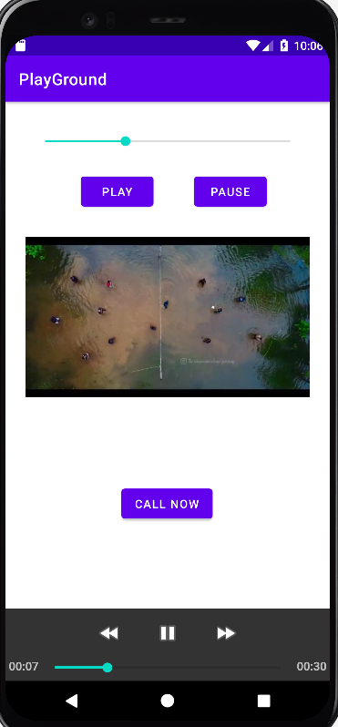 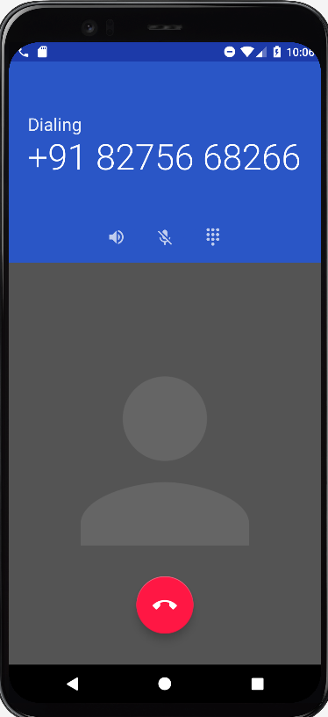

**b. Programming Security and permissions**

**Code:**

**activity_main.xml**

<?xml version="1.0" encoding="utf-8"?>  
<androidx.constraintlayout.widget.ConstraintLayout xmlns:android="http://schemas.android.com/apk/res/android"  
 xmlns:app="http://schemas.android.com/apk/res-auto"  
 xmlns:tools="http://schemas.android.com/tools"  
 android:layout_width="match_parent"  
 android:layout_height="match_parent"  
 tools:context=".MainActivity">  
  
 <Button  
 android:id="@+id/button"  
 android:layout_width="wrap_content"  
 android:layout_height="wrap_content"  
 android:text="Request Permission"  
 app:layout_constraintBottom_toBottomOf="parent"  
 app:layout_constraintEnd_toEndOf="parent"  
 app:layout_constraintStart_toStartOf="parent"  
 app:layout_constraintTop_toTopOf="parent"  
 app:layout_constraintVertical_bias="0.257" />  
</androidx.constraintlayout.widget.ConstraintLayout>

**MainActivity.kt**

package com.example.permissionpract  
class MainActivity : AppCompatActivity() {  
 override fun onCreate(savedInstanceState: Bundle?) {  
 super.onCreate(savedInstanceState)  
 setContentView(R.layout.activity_main)  
  
 button.setOnClickListener {  
 ActivityCompat.requestPermissions(this, arrayOf(Manifest.permission.CAMERA,Manifest.permission.READ_CONTACTS,Manifest.permission.READ_EXTERNAL_STORAGE,Manifest.permission.CALL_PHONE,Manifest.permission.READ_CALENDAR,Manifest.permission.READ_SMS),1)  
 }  
 }  
 override fun onRequestPermissionsResult(  
 requestCode: Int,  
 permissions: Array<out String>,  
 grantResults: IntArray  
 ) {  
 if (grantResults.size > 0 && grantResults[0] == PackageManager.PERMISSION_GRANTED)  
 {  
 Toast.makeText(this,"All Permission Granted!!!",Toast.LENGTH_SHORT).show()  
 }  
 else{  
 Toast.makeText(this,"Permission Denied!!!",Toast.LENGTH_SHORT).show()  
 }  
 super.onRequestPermissionsResult(requestCode, permissions, grantResults)  
 }  
}

**AndroidManifest.xml:**

<?xml version="1.0" encoding="utf-8"?>  
<manifest xmlns:android="http://schemas.android.com/apk/res/android"  
 xmlns:tools="http://schemas.android.com/tools"  
 package="com.example.permissionpract">  
 <uses-permission android:name="android.permission.CAMERA"/>  
 <uses-permission android:name="android.permission.READ_CONTACTS"/>  
 <uses-permission android:name="android.permission.READ_EXTERNAL_STORAGE"/>  
 <uses-permission android:name="android.permission.CALL_PHONE"/>  
 <uses-permission android:name="android.permission.READ_CALENDAR"/>  
 <uses-permission android:name="android.permission.READ_SMS"/>  
 <application  
 android:allowBackup="true"  
 android:dataExtractionRules="@xml/data_extraction_rules"  
 android:fullBackupContent="@xml/backup_rules"  
 android:icon="@mipmap/ic_launcher"  
 android:label="@string/app_name"  
 android:roundIcon="@mipmap/ic_launcher_round"  
 android:supportsRtl="true"  
 android:theme="@style/Theme.PermissionPract"  
 tools:targetApi="31">  
 <activity  
 android:name=".MainActivity"  
 android:exported="true">  
 <intent-filter>  
 <action android:name="android.intent.action.MAIN" />  
 <category android:name="android.intent.category.LAUNCHER" />  
 </intent-filter>  
 </activity>  
 </application>  
  
</manifest>

**Output:**

